Recipient Name
Email address
Re: Response to your email of concern
November 14, 2018

During Canadian Down Syndrome Week, we launched the marketing campaign “Endangered Syndrome.” The goal of the campaign is to raise public awareness and begin a deeper conversation about the challenges that people with Down syndrome face in accessing adequate supports in the key areas of education, employment and housing. The campaign is supported by videos featuring candid interviews with parents, people living with Down syndrome and experts that serve to deepen the dialogue around these challenges.

We are achieving that goal. We have begun a great conversation...a global conversation...and that’s exactly what we wanted to have happen. There has been an incredible amount of engagement for a community whose challenges are largely ignored. The numbers show us that while most of you support us in our goal, for others the campaign created controversy. While we understand a number of people didn’t like this campaign, it was never our intention to offend anyone.

We have heard and respect many individual opinions. We’ve heard stories of your wonderful successes which others only dream of. We’ve heard about the pressure points some continue to work through to gain acceptance and supports for their loved ones. We’ve heard from people who have been working in the disability sector for their entire career, those who remember how life used to be back when. We have also heard about frustration and fear. We are grateful for and thank each of you for your participation.

Our intention is not to compare humans to animals; no one respects or knows better the beauty, strengths and abilities of this community than those of us at CDSS who have children of our own living with Down syndrome. The use of the animal costumes is to provide context only, to highlight the surprising reality that people with Down syndrome do meet the Red List criteria for being considered endangered. The costume designs are empowering and were not intended to dehumanize. Our comparison is to being “endangered” rather than to the animals themselves. Throughout the process of developing this campaign, we paid very careful attention to this. We showcased the vibrant personalities of our cast members first and foremost, rather than masking them in any way.

Many of you have asked about our application to the IUCN Red List and how that would help families. We took this unusual and provocative step in an effort to advocate for the kind of aid, funding, protections, government intervention and public awareness that the Endangered List receives. Making the list would lend support and credibility for our cause and give us the leverage to lobby for increased supports for individuals in the Down syndrome community. To date, we have growing support for the application - a clear signal that many people, like us, see the need for a response and for additional funding to flow to the Down syndrome community. Particularly funding that could enhance supports for education, employment and housing.

Large and sustainable change for our community isn’t easy and at times the road can be rocky. We’ve made significant progress towards improving opportunities for individuals to live productive, equitable and satisfying lives in their local communities. Together, we need a dramatic shift in awareness and attitudes to continue with that progress. In 2016, we answered the 40 most googled questions expectant parents ask after a positive diagnosis providing parents, today and for the future, with the answers they need in the moment they need it most. Last year, we reached out with “Anything but Sorry” to raise awareness that the birth of all babies with Down syndrome should be celebrated. Elements of that campaign were viewed over 1.3 billion times. This year, we raise awareness of inadequate and dwindling supports.
Our community is shrinking and because of that it is often forgotten. Sometimes it takes bold ideas to spark action for change. We have common cause. Creating a provocative campaign is sometimes the best way to make ourselves heard. The needs of our community should not be pushed aside. Aligned, we’ll strengthen both the message and the outcome. Thank you to the dozens of families and professionals who have already sent us ideas for great projects. Together let’s continue to make the community thrive.

We have been bold.

Respectfully,

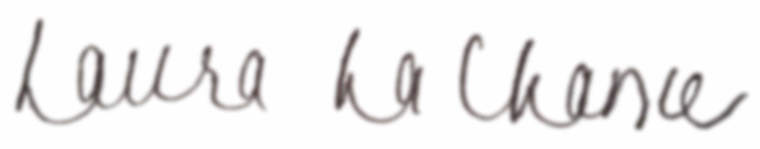

Laura LaChance

